NAME: EKENG, AKANINYENE IME
COURSE: LINUXS FUNDAMENTALS PART1 (CYBERSECURITY)
COHORT: NOVARA 28 NOVERMBER 2025
DATE: 18/12/2025

INTRODUCTION
Linux Fundamentals Part 1 is an introductory practical session designed to help beginners understand the basics of the Linux operating system. Linux is an open-source operating system widely used in servers, cyber security, networking, and software development. This practical introduced basic Linux concepts, how to interact with a Linux machine using a browser, and how to perform simple tasks using commands in the terminal.

OBJECTIVES
The objectives of this practical are to:
- Understand basic background information about Linux.
- Learn how to interact with a Linux machine using the browser.
- Run basic Linux commands in the terminal.
- Navigate and interact with the Linux file system.
- Search for files and directories.
- Understand basic shell operators used in Linux.

PROCEDURES
The following steps were carried out during this practical session:
1. Background on Linux
An introduction was given on what Linux is, its history, and why it is widely used. Linux was explained as a powerful, secure, and flexible operating system commonly used in cybersecurity and servers.
2. Interacting with the First Linux Machine
A Linux machine was launched directly in the browser using TryHackMe. This removed the need for installing Linux locally and allowed easy access to the terminal.
3. Running Basic Commands
Basic commands such as:
- `whoami` (to check the current user)
- `pwd` (to display the current directory)
- `ls` (to list files and directories)
were executed to understand how commands work in Linux.

4. Interacting with the File System
Commands like:
- `cd` (change directory)
- `mkdir` (create a directory)
- `touch` (create a file)
- `cat` (view file content)
were used to navigate and manage files and folders.

5. Searching for Files
The `find` command was introduced to search for files and directories within the system.

6. Introduction to Shell Operators
Basic shell operators such as:
- `&&`
- `||`
- `>`
Were explained and used to understand how commands can be combined and outputs redirected.

OBSERVATIONS
- I observed that linux uses a command-line interface where tasks are performed using text commands.
- I observed that commands are case-sensitive.
- I observed that the file system is organized in a hierarchical structure starting from the root directory.
- I observed that simple commands can perform powerful tasks efficiently.
- I observed that shell operators help combine commands and manage outputs easily.

OUTCOME
At the end of this practical, i was able to:
- Understand basic Linux concepts and structure.
- Use a Linux machine through a browser interface.
- Run basic Linux commands confidently.
- Navigate the file system and manage files.
- Search for files using terminal commands.
- Use basic shell operators effectively.

CONCLUSION
Linux Fundamentals Part 1 provided a strong foundation in understanding and using the Linux operating system. The practical session improved basic command-line skills and familiarized us with Linux file systems and commands. This knowledge is essential for further studies in cyber security, networking, and system administration. Overall, the practical was simple, educative, and very useful for beginners.

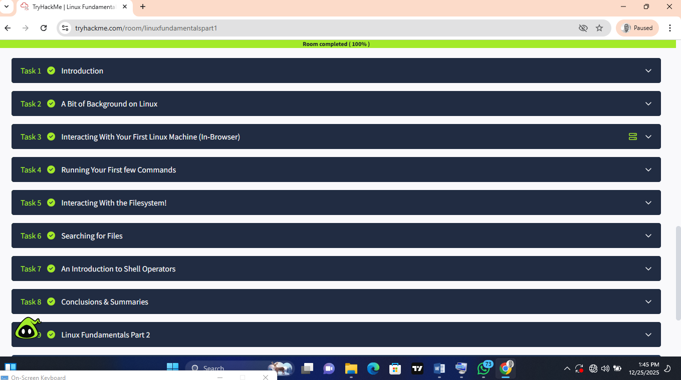
SCREENSHOT OF MY SUCCESSFUL COMPLETION.

